Relocation Assistance Policy
HR Knowledge Hub | Compensation and Benefits | Owner: Sam Whitfield | Last updated: October 30, 2026

Section 1: Executive Summary & Scope
Covers eligibility, reimbursable expenses, and repayment terms for employees relocating for a new role. Section 1 (Executive Summary & Scope) applies to Compensation and Benefits within HR Knowledge Hub and is maintained by Sam Whitfield. Defines the operational charter, scope boundaries, and executive accountability.
Operational requirement 1.1: Relocation packages are tiered by distance: under 50 miles, 50-500 miles, and over 500 miles. Secondary control 1.2: Covered expenses include moving company costs, temporary housing up to 30 days, and one house-hunting trip.
- Relocation packages are tiered by distance: under 50 miles, 50-500 miles, and over 500 miles.
- Covered expenses include moving company costs, temporary housing up to 30 days, and one house-hunting trip.
- Section 1 review cadence is tracked by Sam Whitfield under Compensation and Benefits governance.
Control Area | Owner | Target SLA | Verification Status
Compensation and Benefits | Sam Whitfield | 5 business days | Verified
Relocation Assistance Policy Gate 1 | Sam Whitfield | 3 business days | Active
Relocation Assistance Policy Gate 2 | Sam Whitfield | 10 business days | Monitored
Page 1 of 5 | HR Knowledge Hub | Compensation and Benefits | SharePoint Online

Section 2: Architecture & Process Flow
Covers eligibility, reimbursable expenses, and repayment terms for employees relocating for a new role. Section 2 (Architecture & Process Flow) applies to Compensation and Benefits within HR Knowledge Hub and is maintained by Sam Whitfield. Maps end-to-end process stages, handoff gates, and system-of-record integrations.
Operational requirement 2.1: Covered expenses include moving company costs, temporary housing up to 30 days, and one house-hunting trip. Secondary control 2.2: Relocation assistance must be repaid in full if the employee resigns within 12 months.
- Covered expenses include moving company costs, temporary housing up to 30 days, and one house-hunting trip.
- Relocation assistance must be repaid in full if the employee resigns within 12 months.
- Section 2 review cadence is tracked by Sam Whitfield under Compensation and Benefits governance.
Control Area | Owner | Target SLA | Verification Status
Compensation and Benefits | Sam Whitfield | 5 business days | Verified
Relocation Assistance Policy Gate 1 | Sam Whitfield | 3 business days | Active
Relocation Assistance Policy Gate 2 | Sam Whitfield | 10 business days | Monitored
Sec-2 | Sam Whitfield | 3 business days | Stage 2 Verified
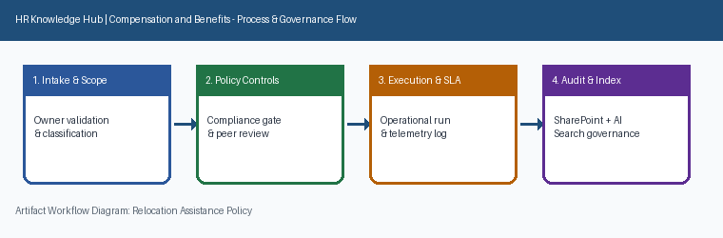
Page 2 of 5 | HR Knowledge Hub | Compensation and Benefits | SharePoint Online

Section 3: Governance Standards & Controls
Covers eligibility, reimbursable expenses, and repayment terms for employees relocating for a new role. Section 3 (Governance Standards & Controls) applies to Compensation and Benefits within HR Knowledge Hub and is maintained by Sam Whitfield. Establishes mandatory compliance controls, approval thresholds, and audit evidence.
Operational requirement 3.1: Relocation assistance must be repaid in full if the employee resigns within 12 months. Secondary control 3.2: International relocations route through the global mobility team, not this policy.
- Relocation assistance must be repaid in full if the employee resigns within 12 months.
- International relocations route through the global mobility team, not this policy.
- Section 3 review cadence is tracked by Sam Whitfield under Compensation and Benefits governance.
Control Area | Owner | Target SLA | Verification Status
Compensation and Benefits | Sam Whitfield | 5 business days | Verified
Relocation Assistance Policy Gate 1 | Sam Whitfield | 3 business days | Active
Relocation Assistance Policy Gate 2 | Sam Whitfield | 10 business days | Monitored
Sec-3 | Sam Whitfield | 10 business days | Stage 3 Verified
Page 3 of 5 | HR Knowledge Hub | Compensation and Benefits | SharePoint Online

Section 4: Operational KPIs & Benchmarks
Covers eligibility, reimbursable expenses, and repayment terms for employees relocating for a new role. Section 4 (Operational KPIs & Benchmarks) applies to Compensation and Benefits within HR Knowledge Hub and is maintained by Sam Whitfield. Tracks baseline performance, target SLAs, and quarterly benchmark progression.
Operational requirement 4.1: International relocations route through the global mobility team, not this policy. Secondary control 4.2: Relocation packages are tiered by distance: under 50 miles, 50-500 miles, and over 500 miles.
- International relocations route through the global mobility team, not this policy.
- Relocation packages are tiered by distance: under 50 miles, 50-500 miles, and over 500 miles.
- Section 4 review cadence is tracked by Sam Whitfield under Compensation and Benefits governance.
Control Area | Owner | Target SLA | Verification Status
Compensation and Benefits | Sam Whitfield | 5 business days | Verified
Relocation Assistance Policy Gate 1 | Sam Whitfield | 3 business days | Active
Relocation Assistance Policy Gate 2 | Sam Whitfield | 10 business days | Monitored
Sec-4 | Sam Whitfield | 5 business days | Stage 4 Verified
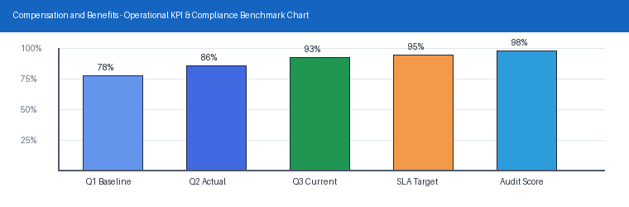
Page 4 of 5 | HR Knowledge Hub | Compensation and Benefits | SharePoint Online

Section 5: Appendix, Lineage & Sign-off
Covers eligibility, reimbursable expenses, and repayment terms for employees relocating for a new role. Section 5 (Appendix, Lineage & Sign-off) applies to Compensation and Benefits within HR Knowledge Hub and is maintained by Sam Whitfield. Records document lineage, governance metadata, version history, and owner sign-off.
Operational requirement 5.1: Relocation packages are tiered by distance: under 50 miles, 50-500 miles, and over 500 miles. Secondary control 5.2: Covered expenses include moving company costs, temporary housing up to 30 days, and one house-hunting trip.
- Relocation packages are tiered by distance: under 50 miles, 50-500 miles, and over 500 miles.
- Covered expenses include moving company costs, temporary housing up to 30 days, and one house-hunting trip.
- Section 5 review cadence is tracked by Sam Whitfield under Compensation and Benefits governance.
Control Area | Owner | Target SLA | Verification Status
Compensation and Benefits | Sam Whitfield | 5 business days | Verified
Relocation Assistance Policy Gate 1 | Sam Whitfield | 3 business days | Active
Relocation Assistance Policy Gate 2 | Sam Whitfield | 10 business days | Monitored
Sec-5 | Sam Whitfield | 3 business days | Stage 5 Verified
Page 5 of 5 | HR Knowledge Hub | Compensation and Benefits | SharePoint Online

